Photos by Rudolf Damec – credits:
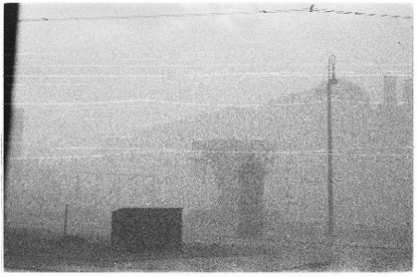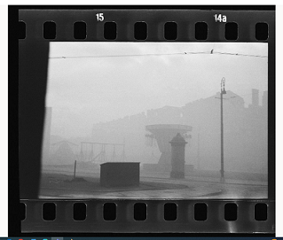
Both photos:
Carrousels and swings enveloped in the smoke from the burning ghetto in the area of Nowiniarska, Bonifraterska and Franciszkańska Streets on the “Aryan” side of the ghetto wall, April – May 1943.
Photo: Rudolf Damec, Rudolf Damec family archive / scan of the negative: POLIN Museum, Archeology of Photography Foundation
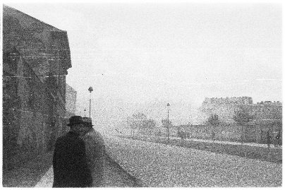
Konwiktorska Street, Polonia SC stadium fence on the right; in the distance, silhouettes of buildings inside the ghetto enveloped in smoke
Photo: Rudolf Damec, Rudolf Damec family archive / scan of the negative: POLIN Museum, Archeology of Photography Foundation
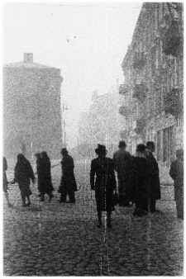
View of the ghetto wall at the intersection of Świętojerska and Bonifraterska Streets and the Krasiński Square. Behind the wall, buildings of the brush makers’ workshop, April – May 1943.
Photo: Rudolf Damec, Rudolf Damec family archive / scan of the negative: POLIN Museum, Archeology of Photography Foundation
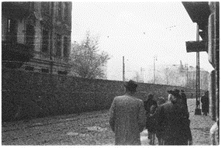
Muranowski Square seen from the side of Przebieg Street; on the left, the house at 7 Muranowska Street, inside the ghetto, April – May 1943.
Photo: Rudolf Damec, Rudolf Damec family archive / scan of the negative: POLIN Museum, Archeology of Photography Foundation
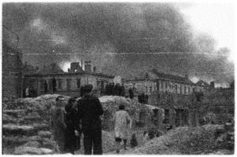
The Holy Spirit hospital buildings at 12 Elektoralna Street, destroyed in 1939; in the background, smoke from the burning ghetto, April – May 1943.
Photo: Rudolf Damec, Rudolf Damec family archive / scan of the negative: POLIN Museum, Archeology of Photography Foundation

