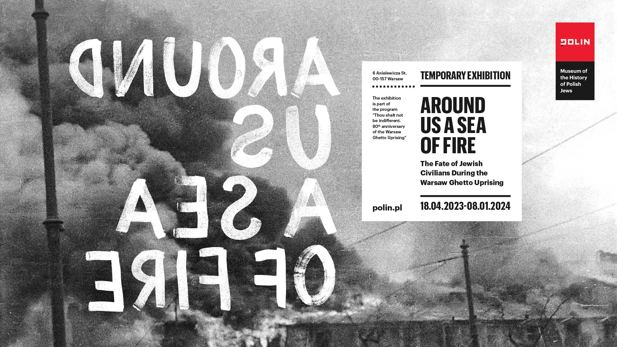

Press release, Warsaw, 13 April 2023

***Around Us a Sea of Fire***

**Exhibition at POLIN Museum to mark the 80th anniversary  
of the Warsaw Ghetto Uprising**

**18 April 2023 – 8 January 2024**

***Around Us a Sea of Fire* is the first exhibition devoted to the Warsaw Ghetto Uprising to focus on the perspective of civilians. During the Uprising, they hid in bunkers and shelters, defying the German system of deportations and mass murder. Instead of responding to summons to turn up for transports heading towards imminent death, they remained in hiding. Their silent act of resistance was as important as armed combat. Words are all they have left behind. POLIN Museum invites you to view and listen to the history of the Warsaw Ghetto Uprising told by twelve protagonists: Hena (Krystyna), Stella, Mietek, Marylka, a man named Maur, Łazarz, Symcha, Leon, Sewek, Mietek, Mira and an Anonymous author.**

19 April 2023 marks the 80th anniversary of the outbreak of the Warsaw Ghetto Uprising—the biggest Jewish armed struggle during the Second World War, and the first urban uprising in Nazi-occupied Europe. On this day, on the eve of Passover holiday, 50,000 civilians were still residing in the Warsaw ghetto. Amongst them were 20-year old Mietek Pachter, 21-year old Mira Piżyc and 11-year old Helena Kuczer (Krystyna Budnicka). They were no fighters, just like very many other residents of the ghetto. What happened to tens of thousands of people who went underground during the Uprising and remained unreachable for many days?

Professor Barbara Engelking, author of the exhibition concept, and Zuzanna Schnepf-Kołacz, the exhibition curator, focused on the experience of the civilians described in their diaries or notes taken during the Uprising or immediately after its suppression:

“We wanted to recall the memory of the nearly 50,000 people who did not belong to underground organizations in the ghetto and didn’t fight with arms in their hands. They remained in hiding—that was their act of resistance against the liquidation of the ghetto. We wish to convey the feelings and emotions of the people who defied German orders to turn up for collections—back than it was obvious to all that deportations means death—and instead retreated to the basements and bunkers,” says Zuzanna Schnepf-Kołacz, exhibition curator.

Most traces of the civilian population during the Uprising were destroyed or burnt. The main source for retelling the story of their experiences and emotions were words that people left behind—gruelling accounts of “hell”, “Dante’s inferno” as they themselves described their situation. The authors thus become our guides through the exposition. Thanks to their words, we will recall the memory of an Anonymous author who hid in the bunker in the vicinity of 44 Miła Street, of lab technician Stella Fidelseid who gave birth to a baby boy in the bunker, of 17-year old Leon Najberg who returned to the ghetto once he’d heard the Uprising was about to break out. Finally, we will get acquainted with the story of Hena Kuczer (today [Krystyna Budnicka](https://sztetl.org.pl/en/oral-history/193195-krystyna-budnicka)), one of the very few people who are still alive and remember the Uprising. Ms Budnicka will share the story of her family in the exposition—the story her parents and seven siblings who all perished in the ghetto.   
The exhibition presents the chapter in the history that **happened right here: in Warsaw, in Muranów**, at the very spot where POLIN Museum stands today. Traces of the stories of the people, the ghetto and the Northern Quarter inhabited by the Jewish population before the war remain hidden beneath the ground. In the exposition, relics from archaeological digs—objects partially burnt or melted in high temperatures, corroded pieces of balustrades, a piece of door handle or a brick—will remind us of those traces. Also, the shell cases excavated from under the ground, reminding us that the execution site for Jews was located at the former 19 Zamenhofa Street.

**In the face of death**

We will see what an everyday life in a bunker was like: what were the living conditions, with whom did people share their hiding space, how they coped with routine activities and needs. Thanks to the **exhibition design by Małgorzata Szczęśniak and Saskia Hellman**, the experience of being inside the bunker will become almost tangible—the heat from burning buildings, darkness, lack of space and air to breathe. The exposition will be accompanied by a **soundscape composed by Paweł Mykietyn**, inspired by 11-year old pianist [Josima Feldshuh](https://sztetl.org.pl/en/tradycja-i-kultura-zydowska/kultura-i-nauka/josima-feldszuh-nastoletnia-wirtuozka-z-getta-warszawskiego) who died of pneumonia in a hideout on the ‘Aryan’ side on the third day of the Uprising.

“We will talk about relations developing between those in hiding, about their feelings and emotions. On the one hand—conflicts, fear, panic attacks, lack of hope and a sense of desolation, abandonment and indifference of the outside world, a sense of a life lost. On the other—a need for love and intimacy, a sense of agency and taking responsibility for others. A will to stay alive, saving oneself and one’s nearest and dearest, building a community whose members would support and protect one another is also a way to combat evil,” says curator Zuzanna Schnepf-Kołacz.

**Photos discovered after decades**

In the exhibition, we will show two sets of photographs, together with original plates, which found their way to the POLIN Museum and the exhibition, almost at the last minute. The first is a set of photographs was taken during the Warsaw Ghetto Uprising by Zbigniew Leszek Grzywaczewski, who worked in the Warsaw Fire Brigade during the war. A total of forty-eight shots were recorded on the film, thirty-three of which depict the ghetto. Aside from the twelve photos that have been published before, held in the form of prints at the Holocaust Museum in Washington and the Jewish Historical Institute, there are images that have never been shown before. These are photos depicting the smoke over the ghetto as well as in the streets and courtyards inside the ghetto, burnt-out houses, firefighters putting out the flames, posing on the roof of a building or eating from mess tins in the street. Many images are repeated, especially those of the burning buildings, the ghetto wall and people being led to Umschlagplatz.

“It seems that Leszek Grzywaczewski tried his best to record these scenes, realising the importance of documenting events inaccessible to the eyes of people on the other side of the ghetto wall. This is the only photographic film that historians of the Holocaust know of which shows the images inside the ghetto. These are unique photos taken by a Pole—not by the German perpetrators who wanted to show the Jews in the worst possible way. The German photos were used for propaganda, such as the report prepared by Jurgen Stroop for Heinrich Himmler,” says Marta Dziewulska, POLIN Museum press officer.

Another set of photos and the accompanying negatives were brought to POLIN Museum by Ms Aleksandra Sobiecka, granddaughter of Rudolf Damec. Such photos—showing the ghetto burning during the Uprising and passers-by looking at it—are very few and far between. In the POLIN Museum collection, there are two colour slides taken by Zbigniew Borowczyk, on display in the Holocaust gallery of the POLIN Core Exhibition. Previously unknown photographs by Rudolf Damec show close-up scenes that took place by the ghetto wall during the Uprising. The author of the photographs gets up close not only to the ghetto wall, but also to the people looking at the ghetto burning behind the wall. You can see their faces, their gestures, their facial expressions, the details of their clothing; we see children, adults, some dressed elegantly, some modestly. We are presented with an image of a world that existed simultaneously to the Holocaust taking place behind the ghetto wall.

"Here’s a man who would walk along the eastern stretch of the ghetto wall and take photos. We know that he had great empathy—he offered a hiding place to a Jewish woman in his home, he was deeply moved by what was happening and he felt a strong urge to document what he saw," Joanna Fikus, head of the POLIN Exhibitions Department commented on Damec’s photographs.

**Thou Shalt Not Be Indifferent**

We present these stories also with today’s world in mind—people whose houses are on fire, who are forced to flee into the unknown seeking rescue for themselves and their relatives; people who feel lonely, helpless and abandoned. Thus, we pose questions that are vital in the present-day reality: how would we behave in the face of death? How do people excluded from society, experiencing indifference and contempt feel? People who are "drowning" (a metaphor often used by the exhibition protagonists), for whom there is no rescue? How can we combat evil, how do we resist it? What is indifference and what does it lead to? Do we feel ashamed when we witness the suffering of others? Visitors to POLIN Museum will have an opportunity to seek answers to these questions along with the scholars, historians, philosophers, artists and witnesses to history in the all-year program run by POLIN Museum titled “Thou Shalt Not Be Indifferent”. The key event of the program is the opening of the temporary exhibition *Around Us a Sea of Fire* on 18 April 2023, on the eve of the 80th anniversary of the outbreak of the Warsaw Ghetto Uprising.

Professor Barbara Engelking, head of the Center for Holocaust Research at the Institute of Philosophy and Sociology, Polish Academy of Science, is the author of the exhibition concept, Zuzanna Schnepf-Kołacz of POLIN Museum of the History of Polish Jews is the curator. The exhibition is co-organised by the Association of the Jewish Historical Institute of Poland and the Center for Holocaust Research.

**The Warsaw Ghetto Uprising**

At dawn on Monday, 19 April 1943, on the eve of Passover, German troops entered the Jewish quarter through a gate on the side of Nalewki Street, intending to carry out its final liquidation. They were met with armed resistance of its inhabitants — several hundred members of the ŻOB and ŻZW. The Warsaw Ghetto Uprising broke out.

Though few in numbers and under-armed, the resistance fighters inflicted losses on German soldiers. They fired at the encroaching troops and pelted them with grenades and petrol bottles. The ŻZW under the command of Paweł Frenkel engaged in heavy combat at Muranowski Square. The image of the Polish and Jewish flags displayed side by side at the Square took on an almost symbolic dimension. Between 20 and 22 April, ŻOB fighters led by Marek Edelman and a ŻZW unit led by Chaim Łopata fought at the brush makers’ workshop. Fighting against German troops also took place in other areas of the ghetto. Meanwhile, the Germans were blowing up the resistance fighters' bunkers to prevent them from moving and communicating. At the same time, they set fire to one house after another.

The fighting continued until mid-May 1943. On 8 May 1943, the Germans surrounded the ŻOB command bunker on Miła Street. Mordechai Anielewicz, the organization’s leader at the time, committed suicide along with other fighters. Thereafter, the resistance fighters still fought occasional skirmishes. Only a few dozen managed to get out of the ghetto through the sewers.

On 16 May 1943, on Jürgen Stroop's orders, the Great Synagogue on Tłomackie was blown up. This was meant as a symbolic acknowledgement of the suppression of the Uprising and the liquidation of the Warsaw ghetto by the Germans.

**Civilian population during the Warsaw Ghetto Uprising**

Several hundred male and female fighters of the Jewish resistance took up arms against the Germans. The remaining ghetto prisoners, some 50,000 "civilian" Jews, stayed in various hideouts and bunkers for weeks. Facing despair, loneliness, hunger, thirst and fear, they fought for every single "day, hour, minute" of staying alive with their nearest and dearest. Though silent, their kind of resistance was as crucial as the armed combat. They remained unreachable for days, staying underground and disobeying German orders. A handful of Jews left alive after the Uprising continued to hide in the rubble left from the ghetto. Dubbed the "rubblers" (Polish: Gruzowcy), they faced a shortage of food and water. They died of exhaustion, or disease or were shot by the Germans. Few managed to cross to the other side of the wall. The last ones left the "ghetto cemetery" in January 1944.

**Graphics:** [www.polin.pl/en/media](https://www.polin.pl/en/media)

**Contact for the media:**

Marta Dziewulska

POLIN Museum Press Officer

[mdziewulska@polin.pl](mailto:mdziewulska@polin.pl)

+48 604 464 675