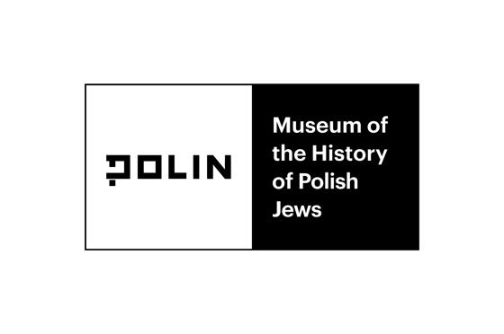
Emotions and history.

How to talk about difficult topics at school?

International conference

Warsaw, November 26-28, 2020

POLIN Museum of the History of Polish Jews

Workshops on the Zoom platform

Workshop dates: November 27, 2020, at 15: 00-17: 00

November 28, 2020, 10: 00-12: 00

Workshop descriptions:

Workshops in English
- “Teaching controversial issues”
Øystein Kobbeltveit (The Falstad Centre)
“Teaching controversial issues” is a course developed by the European Council, in order to combat the rising of anti-democratic forces in Europe. It is a direct response to research that indicates that teachers avoid controversial issues in the classroom in fear of conflict. The course is dialogue-based, and confronts questions such as why and how we teach controversial issues in the classroom.
- Teaching about the Norwegian Nazi collaborators and perpetrators in Norway.
Christian Semb (The Falstad Centre)
History is not black and white. In between there are different shades of gray. During the five-year occupation of Norway many had to adapt to the Nazi-regime, voluntarily or involuntarily. In this landscape we find both resistance, collaboration and perpetration. How and why should we teach about the Norwegian collaborators and perpetrators from the World War II?
The workshop is a combination of discussions and practical exercises.

Workshops in Polish
- “Proud of the war. September '39 in Polish feature films.”
Prof. Piotr Forecki (Adam Mickiewicz University)
Polish memory of the war years is a collection of different events with meanings that are better or worse remembered. One of them is the outbreak of the war in September 1939, referred to simply as “September 1939”, “September campaign” or “defensive war”. Of course, the tools for forming this memory are different. School education, curricula, textbooks, family stories, etc., mobile appliances play an important role in shaping it. Constructing the memory of the war also takes place with the use of various types of "memory media", among which feature films occupy an important place. The main goal of the workshops is the analysis / interpretation of Polish feature films that present the events of this one month when the war broke out.
- “Take over the helm advisedly ¬– dealing with your own and other people’s emotions”
Małgorzata Jakubczak (Polish Institute of Mindfulness)
During the workshops, we will focus on the role of teachers’ self-awareness in building a safe space for exploring and managing students' emotions. Reaching for the tools derived from the mindfulness trend and NVC - Nonviolent Communication, we will look for the most effective solutions, especially in situations that evoke strong emotions. Based on the experiences of the workshops participants, we will choose ways to deal with emotions that are worth cultivating personally, proposing them to students and including them in work with the class.
- “Memory and empathy, or how to interpret the images of the Holocaust with your students”
Izabela Meyza (Forum for Dialogue)
Most of the photographs documenting the Holocaust were taken by the perpetrators. Is it worth using them in working with students? If so, how to balance this perspective while caring for students' emotions that may arise when discussing difficult topics? During the workshop, you will look at a few selected images and learn about a practical exercise that can be performed with students during remote education.
- “History as a game”
Marcin Mitzner (GD Events)
Modern times demand modern solutions. One of the main trends in society is constant rise of popularity of games as a medium. From board games to mobile appliances we are getting used to understanding and observing reality through certain rules. During the workshop we will try to unpack the idea of how games can be useful in education. Our work will be based of the examples of games built around the World War II narrative.
- “The portrayal of war in children’s literature. What to read with your kids?”
Katarzyna Niewczas (POLIN Museum)
Today's publishing market offers us many books for children referring to the World War II. But are all of these books really worth recommending to our students?
During the workshops, we will consider selected items from children's literature and compare them with the “Recommendations on teaching about World War II” prepared by the POLIN Museum. Together, we will discuss what the educational goals we set when inviting children to the war related conversations and what features should the books we discuss in class have.
- “Difficult stories – how to teach and not discourage. The example of the Jewish Museum in Oświęcim”
Maciej Zabierowski (Auschwitz Jewish Center Foundation)
It is a difficult experience to learn about wrongs caused by in-group members. Man has a whole range of strategies to minimize, undermine or completely deny such information, so as not to disturb the positive image of oneself and one’s group. How to deal with it in the context of Polish-Jewish history? During the workshops, we will learn about the results of research in this area and see how they can be used. The classes on the history of Jews from pre-war Oświęcim will be set as an example.
- “Witnessing emotions – working with survivors’ testimonies”
Anna Zatońska (POLIN Museum)
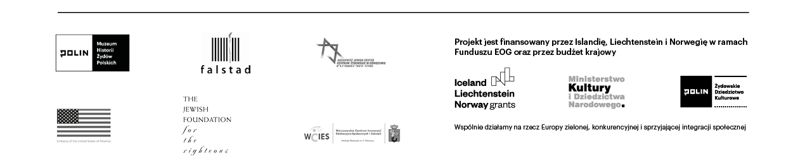
The workshop – based on 5 fragments of Survivors’ testimonies – explores the issue of witness emotions placed within the context of teachers’ – students’ interaction. The participants will be encouraged to share their emotional responses to the testimonies and to discuss possible impact of the stories on their students. We will reflect on the importance of the choice of the narration: its adaptation to the students’ emotional and cognitive development.

