We Preserve the Past and Shape the Future
Education CENTER
of the Polin Museum of the History of Polish Jews
To preserve the past and to shape the future – such is the mission of the POLIN Museum of the History of Polish Jews.
The Education Center has been working towards this goal since 2007, when we held our first exchange program for Polish and Israeli youth. Today we offer a wide array of educational programming for schools, specialists, and the general public.
Our programming is an opportunity to discover the fascinating history and culture of Polish Jews. It is a history which we hope will become a part of your own – accessible, cherished,
and personal. We believe that it is an important history, particularly today as we find ourselves living in a diverse society where we encounter people of different cultures and sensitivities. We would like the Museum’s educational programming to create a space for reflection upon the legacy of the past and for contemplation of the present and the future; a space for encounters with the other, and for finding the other in ourselves.
We invite you to the POLIN Museum!
Programmes for Schools and Teachers
Educational classes for schoolchildren and youth present the 1000-year history of Polish Jews as an integral part of the history of Poland. Workshops, walking tours, competitions and meetings with the witnesses of history teach tolerance, openness, and acceptance for cultural diversity. The POLIN Museum offers exceptional educational tools: from the fascinating Core Exhibition, to temporary exhibits, to the Visual History Archive of the USC Shoah Foundation, which constitutes the world’s largest historical database of witness testimonies.
Conferences, training sessions and meetings aimed at educators offer an opportunity for teachers to deepen their understanding of the history of Polish Jews. The educational programming of the Museum is created in consultation with teachers – ambassadors of the POLIN Museum.
Programmes for Families
The family programming of the POLIN Museum includes workshops around the Jewish holidays, workshops connected with the Core Exhibition, educational and artistic projects for younger children and special events for occasions such as Children’s Day. All activities are based on combining learning with creative entertainment in a family atmosphere. We create a space for meetings where everyone, regardless of their age, can find something that interests them. The educators and artists who conduct these workshops possess not only knowledge, talent, and skills but also, above all, a love of working with small children. The workshops make use of simple materials and expose participants to new ways of spending their free time.

Adult Education
Adult education at the POLIN Museum includes the organization of lectures, discussions, workshops and meetings addressed to both the general public and specialists. Our activities, on the one hand, address the history and culture of Polish Jews, and on the other hand, deal with cultural, ethnic and religious diversity, as well as the challenges of functioning in a diversified society. We invite people to participate in interdisciplinary projects which often draw on both the arts and the humanities. We organise student exchange programmes and international partner projects, and also promote the education of the museum’s employees. We organise artistic residencies where we use various media to explore the issue of Poland’s Jewish legacy and of multiculturalism. It is our goal to make all visitors perceive our institution as an open museum.
We also offer anti-discrimination courses to professional groups, including policemen, judges, and prosecutors. These courses shed light on the social, political, and economic experiences of Poland’s minority groups in order to underscore the importance of anti-discriminatory measures.
An Open Museum, an Accessible Museum
The POLIN Museum tries to reach the greatest possible number of people with its programming. We are continuously looking for channels to reach new groups and communities; we want everybody to feel included in our initiatives. Hence, many local projects are undertaken, such as The Museum on Wheels – an educational exhibition traveling all over Poland, Internet educational platforms and related mobile applications that can be accessed anywhere in the world, as well as publications in both specialised and popular media. We work to make the Museum’s exhibits and programming accessible to all, through tactile graphics, audio-descriptions, trans- lations into Polish Sign Language, and the introduction of integration projects addressed to people with various types of disabilities.
International Programmes
The Education Center of the POLIN Museum carries out various international projects in cooperation with foreign institutions, such as the Polin Academy Summer Seminars, the Jewish Cultural Heritage project and the March of the Living. We focus on fostering new encounters, exchanging experiences, and creating networks of cooperation. We also seek to combat stereotypes through initiatives such as the Polish Intercultural Youth Encounters PIYE programme for Polish and Israeli youth, as well as the broader PIYE Summer School project, which caters to youth from Poland, Israel, and Germany. In the future, we plan to extend this programming to include youth from other countries, as well.
Discover the POLIN Museum!
Museum tours with guides and educators.
At the POLIN Museum, guides and educators help visitors discover the thousandyear history, tradition, and culture of Polish Jews. They take visitors through both the Core Exhibition and temporary exhibits and lead tours of the Museum building, as well as wider Jewish Warsaw – guiding visitors in both Polish and English. Tours in other languages can be arranged through appointments made ahead of time. Our guides and educators are experts in the field of Polish Jewish history, who continuously build upon their qualifications through participation in conferences, seminars, and training workshops.
The Joint Cultural Institution
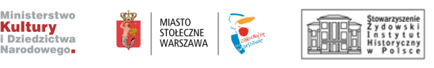
Supported from the Norway and EEA Grants by Iceland, Liechtenstein and Norway
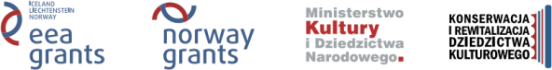
www.eeagrants.org www.norwaygrants.org

Educational programs of The POLIN Museum of the History of Polish Jews are possible thanks to the support of:
The Association of the Jewish Historical Institute of Poland; Taube Philanthropies and Koret Foundation;
Tomasz Ulatowski and Ygal Ozechov; Boeing; Nissenbaum Family Foundation;
The William K. Bowes, Jr. Foundation; Phyllis Cook; Kronenberg Foundation;
Lifelong Learning Programme
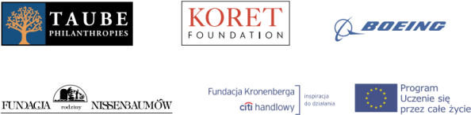

POLIN Museum of the History of Polish Jews Anielewicza Street 6, 00-157 Warsaw www.polin.pl
reservation: phone 0048 22 47 10 301 www.polin.pl/en/reservation

